AI Response Quality Evaluator Agent

Introduction
The AI Response Quality Evaluator Agent is an intelligent system designed to evaluate the quality of responses generated by Artificial Intelligence (AI) applications.
Modern AI systems, such as chatbots, virtual assistants, Retrieval-Augmented Generation (RAG) systems, and coding assistants, can sometimes generate incorrect, irrelevant, incomplete, or unsupported information. These errors reduce the reliability of AI applications.
Manually checking every AI-generated response is time-consuming and difficult when dealing with large amounts of data. Therefore, this project aims to automate the evaluation process using multiple AI judge agents.
The system evaluates responses across different quality dimensions, identifies potential hallucinations, provides explanations for assigned scores, and generates an overall quality verdict.

Problem Statement
AI-generated responses are not always accurate, relevant, complete, or supported by reliable evidence. Existing manual evaluation methods require significant human effort and may produce inconsistent results.
There is a need for an automated and explainable system that evaluates AI-generated responses, identifies unsupported claims, measures response quality, and provides detailed feedback. The proposed system addresses this problem using a multi-agent evaluation pipeline supported by reference documents, evidence retrieval, and scoring analytics.

Objectives
The main objectives of the project are:
- To develop an automated system for evaluating AI-generated responses.
- To assess responses based on relevance, accuracy, completeness, and factual grounding.
- To detect potential hallucinations and unsupported claims.
- To provide scores and explanations for each evaluation dimension.
- To support both single-response and batch evaluation.
- To visualize evaluation results through an interactive dashboard.
- To improve transparency and reliability in AI system evaluation

What is an Agent?
An AI agent is a software component that performs a specific task using instructions, data, and sometimes a language model.
In this project, each judge agent has a dedicated responsibility. Instead of asking one AI model to evaluate everything at once, the system divides the evaluation into smaller tasks.
For example, one agent checks relevance, another checks factual correctness, and another identifies unsupported claims. A final agent combines their results.
These are logically separate agents; they do not necessarily require separate AI models.

The five agents:
- Relevance Judge Agent - Determines whether the AI response directly answers the user's question.
Example: If the question asks for the advantages of machine learning but the answer discusses only its history, the relevance score should be low.
- Accuracy Judge Agent - Checks whether the factual statements in the response agree with a supplied reference answer or source document.

Example: If a reference states that the Earth revolves around the Sun, an answer claiming that the Sun revolves around the Earth contains a factual contradiction.
- Hallucination Detection Agent - Identifies claims that are not supported by the available evidence or that contradict the reference source.

Example: If a document does not mention a person's award, but the AI claims that the person won a specific award, the claim should be flagged as unsupported.

An unsupported claim is not automatically false; it requires verification.

- Completeness Judge Agent - Checks whether the answer covers all the important parts of the question.

Example: If a question asks for the definition, advantages, and disadvantages of AI, an answer containing only the definition is incomplete.

- Verdict Agent - Combines the scores from the four judge agents, applies the scoring rules, and generates the final quality verdict.

Example: The final result may contain an overall score, a PASS/FAIL/REVIEW decision, the major issues found, and suggestions for improvement.

What is hallucination in AI?
AI hallucination occurs when an AI system generates information that is incorrect, fabricated, or unsupported by the available evidence.
Examples include:
- Inventing research papers, authors, or citations.
- Providing incorrect facts or numerical values.
- Making claims that contradict the supplied document.
- Adding details that cannot be verified from the available sources.
Hallucination detection is important because a response may sound confident and well-written while still containing incorrect information.

What is RAG?
RAG stands for Retrieval-Augmented Generation.
It is a technique that retrieves relevant information from an external knowledge source and provides that information to a language model as context.
In this project, RAG helps the evaluator compare an AI response with relevant evidence rather than relying only on the judge model's internal knowledge.
The RAG process works as follows:
- The user uploads a reference document, such as a PDF.
- The system extracts text from the document.
- The extracted text is divided into smaller sections called chunks.
- Each chunk is converted into a numerical representation called an embedding.
- The embeddings are stored in a vector database, such as FAISS.
- When evaluating a response, the system retrieves chunks relevant to the question and answer.
- The judge agents use the retrieved evidence to evaluate factual claims.
RAG improves evidence-based evaluation, but retrieval errors can still occur. Therefore, the system should display the supporting evidence and identify cases where evidence is insufficient.

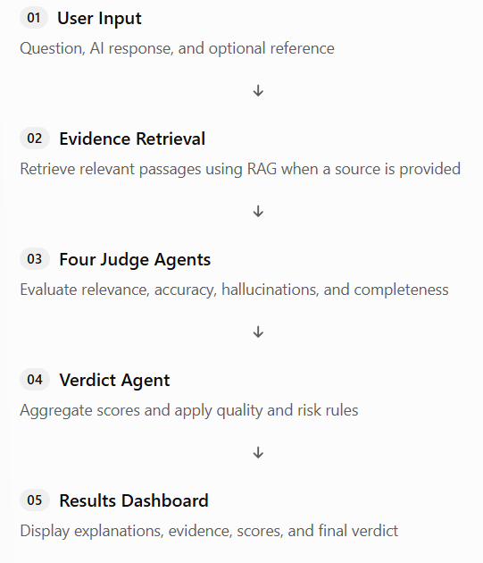
System Workflow

The system supports two evaluation modes:
- Single evaluation: Evaluates one question-answer pair and immediately displays the results.
- Batch evaluation: Evaluates multiple question-answer pairs from a CSV file and summarizes their performance.

Modules of the project
Module | Purpose
Evaluation Input Module | Accepts questions, AI responses, and optional reference data.
Reference Knowledge Base and RAG Module | Stores documents and retrieves evidence for evaluation.
Multi-Agent Judging Pipeline | Coordinates the four judge agents and the Verdict Agent.
Scoring and Reasoning Module | Displays individual scores, explanations, and evidence.
Batch Evaluation Module | Processes multiple responses and exports results.
Dashboard and Analytics Module | Visualizes scores, pass rates, hallucination flags, and quality trends.

Technology Stack
These are suitable technologies for implementing the project.
Technology | Application
Python | Core programming language
Streamlit | User interface and dashboard
Gemini API or another LLM API | Powers the judge agents
Sentence Transformers | Generates text embeddings
FAISS | Stores and retrieves vector representations
PyMuPDF | Extracts text from PDF documents
Pandas | Processes batch evaluation datasets
Plotly | Creates interactive charts
Pydantic | Validates structured agent outputs
Expected Outcome
The expected outcome is a functional AI Response Quality Evaluator Agent that accepts individual or batch AI responses, evaluates them across four quality dimensions, identifies potentially hallucinated claims, provides explanations and supporting evidence, and generates an overall quality verdict through an interactive dashboard.
The completed system will demonstrate how automated AI evaluation can help developers test and improve the reliability of AI-powered applications.

